

County Housing
Hillsdale Housing Authority
Pagedale Housing Authority
Olivette Housing Authority

SECTION 3 RESIDENT APPLICATION

Completed applications should be submitted to
section3@countyhousing.org
Or delivered to:
8865 Natural Bridge Road
St. Louis, MO 63121

Definitions

Section 3 worker
- Any worker who currently fits, or when hired within the past five years, fit at least one of the following categories, as documented:
  - The worker's income for the previous or annualized calendar year is below the income limit established by HUD.
  - The worker is employed by a Section 3 business concern.
  - The worker is a YouthBuild participant.
- The status of a Section 3 worker shall not be negatively affected by a prior arrest or conviction.
- Nothing in this part shall be construed to require the employment of someone who meets this definition of a Section 3 worker. Section 3 workers are not exempt from meeting the qualifications of the position to be filled.
Targeted Section 3 worker for housing and community development projects is a Section 3 worker who:
- Is employed by a Section 3 business concern: or
- Currently fits, or when hired, fit at least one of the following categories, as documented within the past five years:
  - Living within the service area or the neighborhood of the project, as defined in 24 CFR § 75.5; or
  - A YouthBuild participant.

Name

Physical Address

City, State, Zip

Mailing Address, if different

City, State, Zip

Telephone Number, including area code

Email

I am a Section 3 resident because (choose one):

Persons seeking the Section 3 worker preference shall demonstrate that it meets one or more of the following criteria currently or when hired within the past five years, as documented:
- A low or very low-income resident (the worker’s income for the previous or annualized calendar year is below the income limit established by HUD); or
- Employed by a Section 3 business concern; or
- A YouthBuild participant.

Persons seeking the Targeted Section 3 worker preference shall demonstrate that it meets one or more of the following criteria:
- Employed by a Section 3 business concern; or
- Currently meets, or when hired, met at least one of the following categories as documented within the past five years:
  - Living within the service area or the neighborhood of the project, as defined in 24 CFR Part 75.5; or
    - A YouthBuild participant.

Please circle the income range that meets your total household income*.

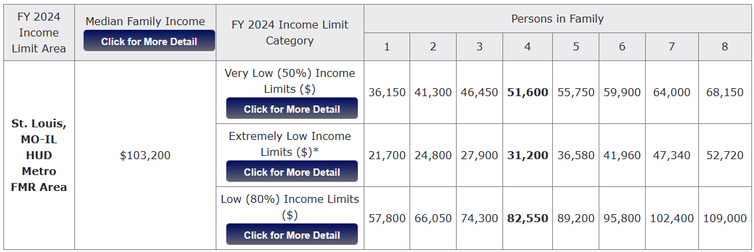
- My household has no income.
(Complete the Zero Income Statement on Page 6 of this application describing how you survive without income.)

*The requirement of proof of income is waived for current public housing residents or Housing Choice Voucher residents with a valid re-certification on file, if applicable.

Section 3 Priority List

For training and employment, four categories of low-income persons (called Section 3 residents) receive priority. Check any that apply to your application.
  - Residents living near a HUD-assisted project; if applicable, please explain:

  - Participants in YouthBuild programs; if applicable, please attach a copy of your completion documents.

  - Homeless persons: if applicable, please attach a letter from the shelter where you receive assistance, regardless of the type of assistance you receive.

  - Other Section 3 eligible residents, including residents of public and assisted housing, if applicable please attach a copy of your current lease agreement and/or benefits.

Fields of Experience and Interest

If you have skills in a particular area and you are interested in working in that field, please check the “Interest” box and provide your length of experience.

Construction-Related  Services | Interest | Length of  Experience | Non-Construction/Post-  Construction Services | Interest | Length of  Experience
Architecture |  |  | Appraisal Services
Bricklaying |  |  | Archeology
Carpentry |  |  | Building Inspection Services
Cement/Masonry |  |  | Building Maintenance
Demolition |  |  | Catering
Drywall |  |  | Computers/IT
Electrical |  |  | Courier Services
Elevator Construction |  |  | Engineering
Engineering |  |  | Janitorial
Environmental Services |  |  | Landscaping
Fencing |  |  | Legal Services
Flooring Installation |  |  | Management Consulting
Heating |  |  | Marketing/Photography
Insulation/Siding |  |  | Printing
Iron Works |  |  | Real Estate Services
Landscaping |  |  | Security
Machine Operation |  |  | Surveying Services
Painting |  |  | Transportation
Plastering |  |  | Other:
Plumbing |  |  | Other:
Roofing |  |  | Other:
Other: |  |  | Other:

Required Documents

Submit the following with this application:

- Proof of Identity (a photo ID: state-issued, college, employee badges are all accepted)

- Proof of Residency (a piece of official mail such as a utility bill, paycheck stub or government document with your current address on it)

- Income Documentation for last 30 days* (most recent W-2, paystubs, Social Security/SSI/SSDI income statement, unemployment statement, worker’s comp award letter, and any other item which would be considered cash income). Non-cash items like food stamps aren’t needed. *This requirement is waived for current public housing residents or Housing Choice Voucher residents with a valid re-certification on file, if applicable.

- Zero-income statement (if applicable)

- Any applicable supporting documentation for Section 3 Priority List (refer to page 2)

Applicant Certification

I understand that Section 3 Resident certifications are valid for three (3) years. It is my responsibility to contact the office that holds my certification in order to update my contact information and my qualifications or if I no longer wish to be a certified Section 3 Resident.

I understand that a Section 3 Resident certification is not an offer of employment. By signing this document, I give the Housing Authority of St. Louis County permission to place my contact information on a list to be shared with businesses and community partners when they are hiring for Section 3 covered projects in the area. I may or may not be contacted about a position. If contacted, I will have to undergo the job application or interview process of that potential employer. If selected, I agree to comply with all federal and local reporting requirements.

I understand that a more detailed review of my information may be requested for any reason.
I affirm that the information I provided was true to the best of my knowledge and belief, and that I have not withheld information in order to obtain certification. I further understand that if I have failed to provide truthful information, or to provide all information, I will be removed from the certification list and will not be able to reapply for one (1) year.

Signature of Applicant Date

Zero-Income Statement (if applicable)

If your household has no income, complete this section. If homeless, attach a letter from the shelter where you receive assistance, regardless of the type of assistance you receive.

I, , certify that no one in my household has any income. I understand this to mean wages from work, unemployment, TANF, SSI/SSDI, Social Security, or any other program which I would receive a cash payment from.

The reason I am able to survive with no income is because (choose one):

- I am currently homeless. I am able to meet my basic needs by doing the following:

- I am living with someone who is not in my household who provides me with support.

Their name is:

Their telephone number is:

Their relationship to me is (mother, uncle, friend, etc.):

To be filled out by the supporting party: How do you provide support to the applicant? Provide approximate cash amounts for all major expenses ($50 or more). Example: “I pay
$500 in rent; I spend $200 on food that he/she shares with me”, etc.:

Signature of Supporting Party: Date:

Signature of Applicant: Date:

